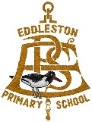
P2-4 Term 4 Home Learning Overview
Majority of learning will be consolidating previous learning through activities and tasks.

Literacy
Reading:
Every week there will be a differentiated reading task.

If there is any difficultly accessing the ebooks, then please contact me. At the moment we are using Youtube and Oxford Owl as a reading resource.

The reading can be completed like their previous reading homework. It does not need to be read all in one day. Pupils would benefit if they read to an adult. However, the reading task could be completed independently for some.

This term we are focusing on: Understanding of different texts (fiction and non fiction)

Through questions (quizzes) children will be assessed on:
- Can identify the main ideas of texts.
- Can answers literal, inferential and evaluative questions about texts.
- Can asks questions to help make sense of a text.
- Can recognises the difference between fact and opinion.
- Can offer own ideas about characters, writer’s use of language, structure and/or setting.
- Can offers own ideas about the writer’s message and, when appropriate, relates these to personal experiences.
Writing:
Every week there will be a differentiated writing task (it may be linked to the reading task).

There will be a rotation of focus every week (VCOP). Children will be asked to mainly include one of the following.
V – Vocabulary (good wow words)
C – Connectives (linking words like: and, then, so, because)
O – Openers (sentence openers like: Next, After, Suddenly)
P – Punctuation (use full stops, exclamation marks and question marks)

Writing activities will include:
- Dairy entry
- Imaginative
- Instructions
- Letter
- Newspaper report
- Poetry
- Recount

Pupils can handwrite or type their writing.

Pupils will also have weekly spelling words to practise. Ideas for activities are available on the ‘Parent Home Learning Guide’.

Numeracy/Maths
Numeracy:
For numeracy, we are going to focus on consolidating the 4 main mathematical processes. These may be rotated or lead to developing a new skill once a skill has been achieved:

- Addition
- Subtraction
- Multiplication
- Division

To assess pupil’s development with these processes, they will be given a written task to complete.

If pupils are finding any tasks challenging, then please encourage them to email me.

Maths:
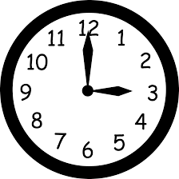
For maths, we are going to focus on life skills:

- Time
- Money
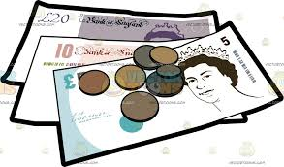
Learning will mostly be active. However, may lead to some written tasks in order to assess progress.

Asking pupils to regularly tell the time or follow a timetable will help them develop their time skills and knowledge.

Allowing children to play/explore with money (change and notes) will encourage children to use correct vocabulary and confidence when handling money.

Health & Well-being

For Health and Well-being, we will be focusing on Growth Mind-Set/Positive Thinking.
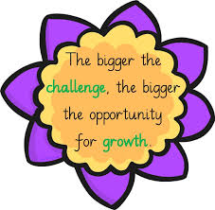
We are going to learn about:

- The brain and how it learns.
- - About the different mind-sets
- - Find out about growth mind-set thinking
- - Discuss negative and positive self-talk.
- - Recognise effort over success

This will be achieved through links to academic videos, research, activities and discussion.

Topic
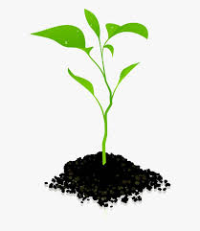
For topic this term, we are going to be learning about Plants.

We are going to learn about:
- What a plant needs to grow
- Structure of plants
- How water is transported within plants
- Common wild and garden plants
- Life cycle of flowing plants (including pollination, seed formation and dispersal)
- Trees (deciduous and evergreen)
This will be achieved through cross-curricular tasks, such as Literacy, Maths, Technology, Science and Expressive Arts.

This Overview is to allow parents to be aware of the focuses during this terms ‘online’ learning session.

Please do not feel that your child must complete every activity on the weekly ‘Home Learning Grid’.

We want to motivate children to use their imagination and develop their creative skills. If parents/children read the weekly ‘Home Learning Grid’ and it sparks an idea, which suits your home situation/resources, then please encourage children to create and complete individual tasks.

We would really appreciate it, if parents/pupils could continue to share activities, which are being completed at home by sending photos. These can include life skills (please see Parent Home Learning Guide).

Thank you

