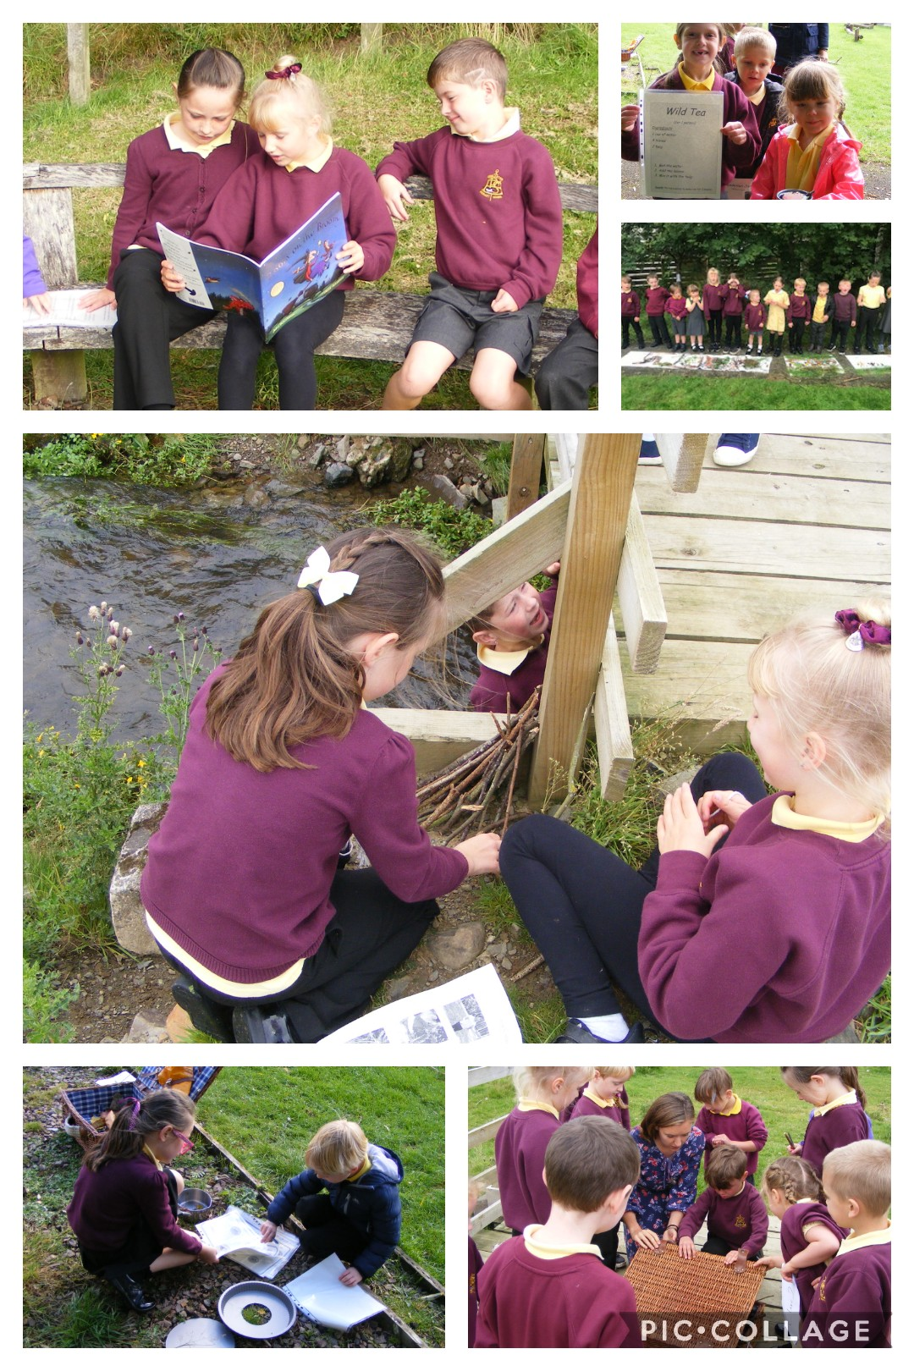
Eddleston Outdoor Learning Policy
We love the outdoors because it supports our health and learning by giving us the space, resources and joy we need to succeed. Eddleston Primary Pupil Voice Outdoor Learning Statement

Outdoor Learning at Eddleston Primary School
- Outdoor learning should make learning enjoyable, meaningful and relevant for all learners (Learning and Teaching Scotland, 2010).
- The school grounds and surrounding areas should be utilised in such a way that Outdoor Learning lessons are supporting all areas of the curriculum.
- Outdoor learning should allow an environment which offers learning opportunities that are not available indoors (Tovey, 2007).
- Outdoor learning should encourage each learner’s curiosity, as well as, create contexts for developing problem solving, persistence and respect for the natural world (Bruce, 2012).
- Learning outdoors can improve mental and physical health.

Outdoor Learning Aims
- Planning for outdoor learning evident in weekly and termly planning.
- Learner centred by listening to pupils’ ideas and interests during planning and evaluating lessons
- Utilise the school grounds and surrounding countryside to their full potential for supporting the whole curriculum
- Create and maintain partnerships with parents and the community to support outdoor learning

The Outdoor Learning Pupil Voice Group created a survey in 2020. The results of the survey are as follows:
- Children wish to take part in three outdoor learning sessions per week
- Learning should include visiting a variety of local sites as well as day trips
- Learning should cover all areas of the curriculum
- Children agreed opportunities for working with other classes should be made available on specific days such as the termly “Themed Outdoor Learning Days
Outdoor Learning Planners
“Importantly, planning should allow for ‘spontaneous’ or pre-planned, ‘off-the-shelf’ local visits when, for example, weather conditions are suitable or favourable.” (Learning and Teaching Scotland, 2010).

- The outdoor learning planners should be used with a child centred approach. This may be by consulting with learners to decide areas they wish to focus on or by identifying next steps in learning.
- Planners should be used alongside whole curriculum planning so as to make links with and support all areas of learning.
- Planners should be used to identify curriculum links and skills as well as specific lesson ideas. These documents can be highlighted or copied onto other planners.
- Complete plans, with assessment and evaluations, should be saved on the Eddleston Primary School server to create a bank of lessons and ideas for future use.
- When a teacher creates an engaging lesson, this should be added to the list of lesson ideas on the original planner.

Whole School Outdoor Learning Days

Term Date | Theme | Resources | Outline
Term 1 August- October | Literacy Outdoor Learning Day | Reading and writing planners for Early to Second Level.  Choose reading or writing as a focus for whole school. | • Begin the day with a whole school introduction explaining the purpose and aims of the day. This could be in assembly form or as a gathering in the outdoors.  • Each class should have their own set of learning activities planned for a day full of outdoor learning based around “Literacy Outdoor Learning Day”.  • Record children’s learning through photographs and short videos.  • Create an online exhibition to showcase what each class was learning in the outdoors.
Term 2 October- December | Maths Outdoor Learning Day | Maths planners for Early to Second Level.  Choose from measurement, shape, etc as a focus for the whole school. | • Begin the day with a whole school introduction explaining the purpose and aims of the day. This could be in assembly form or as a gathering in the outdoors.  • Each class should have their own set of learning activities planned for a day full of outdoor learning based around “Maths Outdoor Learning Day”.  • Record children’s learning through photographs and short videos.  • Create an online exhibition to showcase what each class was learning in the outdoors.
Term 3 January- April | STEM Outdoor Learning Day | Maths planners for Early to Second Level.  Science Planners for Early to Second Level.  Technologies planners for Early to Second Level. | • STEM projects to be chosen by teachers prior to “STEM Outdoor Learning Day”  • Children split into mixed groups with children from all classes. Children may be given or choose roles within the group where appropriate.  • Each group given a STEM project to complete and be ready to share in the afternoon. This project could include but is not limited to: conducting and recording an experiment, photographing evidence, building a model and creating a poster or presentation to show case what they have been learning.  • Allocated time in the afternoon for mixed groups to share their learning.
Term 4 April- June | Sustainability Outdoor Learning Day | Technologies and Social Studies Care for the Environment Planner | • Each class to choose a project to undertake before the day so that resources and necessary community links are organised prior to whole school “Sustainability Outdoor Learning Day”.  • Projects could include but are not limited to: composting, sponsored litter pick, building a bug hotel, creating a wildflower garden, bird watching etc Refer to “Technologies and Social Studies Care for the Environment Planner”.  • Opportunities for children to record their project throughout the day using ICT for photographs and videos.  • Opportunity arranged for children to share their sustainability and conservation efforts with the wider community. This may be by sharing on an online platform, creating posters or leaflets or inviting members of the public for a short presentation in the afternoon.

Pupil Voice Group Aims
The purpose and aims of the Outdoor Learning Pupil Voice Group include:
- Creating opportunities for every pupil voice to be heard in relation to improving Outdoor Learning at Eddleston Primary School
- Continued development and upkeep of school grounds with support from pupils, teachers, parents/carers and other partnerships.
- Review and support of “Outdoor Learning Pupil Responsibilities”
- Creation of surveys, presentations, posters and other forms of communication with the school and wider community in relation to Outdoor Learning.
- Pupil led projects on “Theme Days” and throughout the year

Outdoor Pupil Responsibilities
TBC

References
Bruce, T (2012) Early Childhood Practice: Froebel Today, London: SAGE Publications.

Learning and Teaching Scotland. (2010) Curriculum for excellence through outdoor learning. Online at https://education.gov.scot/Documents/cfe-through-outdoor-learning.pdf Last accessed: 24/03/2021

Tovey, H (2007) Playing Outdoors: Spaces and Places, Risk and Challenge. Maidenhead: Open University Press

