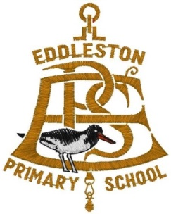

**Eddleston Primary School**

**Newsletter 2: October 2019**







**Head Teacher:** Miss Lorna Murdoch

**Address:** Eddleston Primary School, Burnside, Eddleston, Peebles, EH45 8RH.

**Website:** www.eddlestonprimary.co.uk

**Twitter:** @EddlestonPS

**Learning Community:** Tweeddale

**Head Teacher’s Welcome **

Dear Parents/Carers,

WOW! What an interesting and exciting first few weeks I’ve had in post!

I have very much enjoyed gaining an insight into and getting to know Eddleston Primary, our learners, our staff, our parents/carers and our local community.

Our learners have been engaging in some very exciting learning and have been showcasing some of this on our new Twitter page, which many of you now follow.

Please enjoy looking through our newsletter with updates on what learning our pupils have been/will be involved in.

Kind regards

***Miss Lorna Murdoch***

Head Teacher

**Winter weather **

As we head into the winter session, the days begin to get colder and wetter! Thus, we ask that you ensure that your child comes to school appropriately dressed for this weather. This includes wearing a warm jacket/coat and appropriate footwear for wet and cold weather.

**Staffing update**

Mrs S. Walker is currently working with us for the interim period in P2-4.

After the interview process, I can now confirm that we have a ‘preferred candidate’. Once all checks have been confirmed, I will then be able to release details regarding the preferred candidate, including a start date.

**‘Tweed Reads’**

Our Primary 5 & 6 pupils have now started working in partnership with Peebles High School and their ‘Tweed Reads’ project. Mrs Stewart and two PHS pupils delivered their first assembly to us and have already been working with pupils! Please ask us our pupils about the project.

**Concerns/Issues**

If you have any concerns regarding your child at Eddleston, please do not hesitate to contact your child’s Class Teacher in the first instance. We will continue to always do the best that we can to assist and support in every way possible.

**Parent Council**  

**Chair:** Mr Alan Wise

**Next meeting**

**Date:** Thursday 28th November 2019

**Time:** 6:30-8:30pm

**Location:** Eddleston Primary

**Future meeting dates**

23rd January 2020

26th March 2020

14th May 2020

**eTwinning **

Our staff are beginning to work towards developing a partnership project in our P2-4 and P5-7 classes with Primary Classes in France as part of an eTwinning project. This is a very exciting project for pupils to be a part of, where they will engage in lessons with an international learning focus. We will keep you posted with updates on our progress!

**Coffee morning**

Due to us having lots of exciting activities going on, we are postponing our parental engagement coffee morning until term 2. A date will be confirmed early in term 2.

**Playground noticeboard**

Please note that our playground noticeboard has been updated and will detail school and school-related local community news/updates. If you would like to display anything, please contact the school office.

**Wider achievements**  

At Eddleston Primary, we feel that it is very important for us to recognise that our pupils achieve both inside and out with school. Thus, we feel that it is important for our pupils to share these successes with their peers.

These achievements could include musical successes, sport or an achievement in a specific hobby.

Please let us know about any achievements outside school that your child would like us to know about – we would be delighted to highlight these at our weekly assembly. Please send in or email certificates/details to the School Office.

**Absence reporting**

If your child is going to be absent from school, please ensure that you let the school office know by 9am. This allows us to notify the Class Teacher of the absence and to contact urgently, any parents/carers whose child has not been registered at school that morning.

**School bell **

We have now had an electronic bell installed to the school. This will make transitioning easier for pupils and staff. The ‘old’ school bell will still be used by pupils to alert staff in the playground to a visitor, emergency situation or otherwise.

**Eddleston Horticultural show**

Our pupils had a lot of success at the Eddleston Horti Show! Many pupils came 1st, 2nd & 3rd place with their beautiful artwork! All staff were very proud of them!

**Acknowledgements**  

We would like to say a massive thank you to the Parent Council again for assisting with the cost of the whole school going to a Pantomime in December. The pupils are very much looking forward to seeing ‘Cinderella’ at Brunton Theatre.

**Flu immunisations**  

Please note **another change** of date for the flu immunisations.

**New date – Tuesday 8th October 2019**

**Digital School Award**

We have now registered with the Digital School Award for Scotland and look forward to beginning our digital journey to achieving the prestigious ‘Digital School Award’. We will keep you updated with our progress.

**EuroQuiz**

Our Primary 6 pupils have registered to take part in the National ‘EuroQuiz’ hosted by SEET (Scottish European Educational Trust) next March. This will comprise of a team of 4 pupils who will initially compete in the SBC heats and if successful, compete at the Scottish Parliament next May.

**School resources**

We are in the process of purchasing some new and exciting resources to assist with planning and preparing innovative lessons for our pupils. The resources we are purchasing include Numeracy & Literacy resources, P.E equipment and musical instruments. These resources will complement our current range of materials/resources we have in school.

**‘Maths’ Week Scotland’** 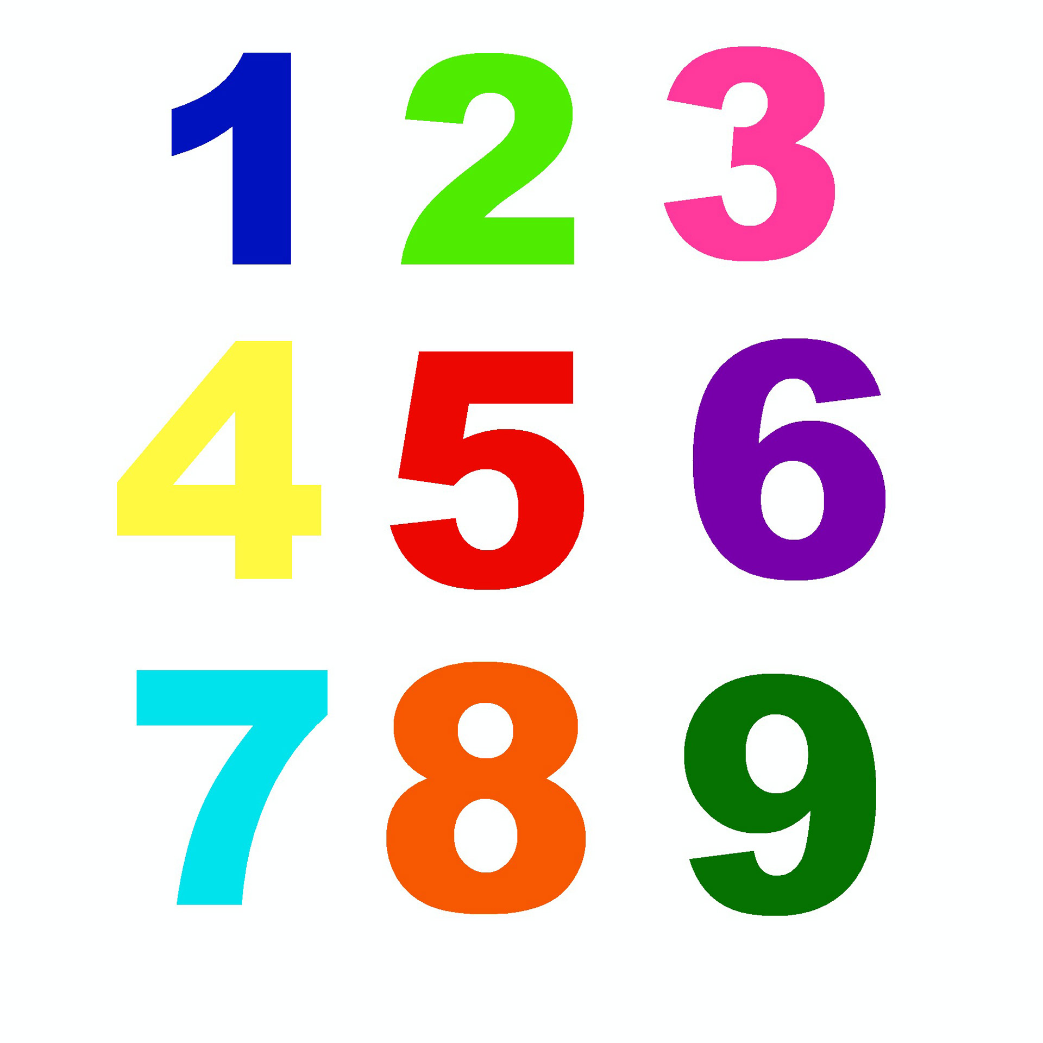

Our ‘Maths’ week’ was organised by our Numeracy Champion, Mrs Taylor, who organised a range of activities for both classes, which started with a whole school outdoor learning lesson! Please see our Twitter page for photographs! A big thank you to Mrs Taylor for organising all the activities.

**Pupil Council**

We are currently in the process of re-establishing our Pupil Council. Each stage will be represented by a pupil and will be pupil-led with a key focus on pupil voice across the school. The pupils will be looking at suggestions and ideas as to how they can improve the school. We will keep you updated on our progress once the Council has been established.

**Cringletie House**

Some of our P7s will be attending the opening of the Nature Trail at Cringletie House on the 24th October. Eddleston has worked in partnership with Cringletie to develop an outdoor classroom and trail. Please look out for our Press release!

**‘Scottish Youth Film Festival’**



Our P5-7 class will be working with two BAFTA nominated film-producers from ‘Into Film’ on a Literacy based media project. This is an exceptionally exciting and rewarding project to be involved in and we very much look forward to welcoming them to Eddleston!