

**Eddleston Primary School**

**Newsletter 2: September 2021**

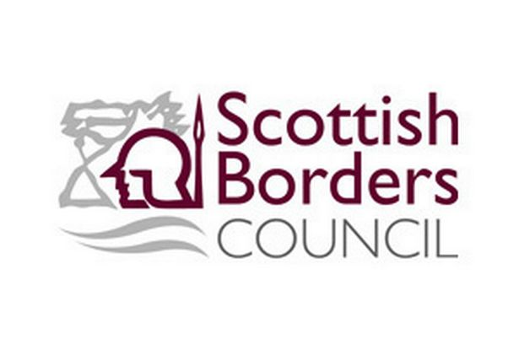





**Address:** Eddleston Primary School, Burnside, Eddleston, Peebles, EH45 8RH.

**Website:** www.eddlestonprimary.co.uk

**Twitter:** @EddlestonPS

**Learning Community:** Tweeddale

**Head Teacher’s Welcome**

Dear Parents/Carers,

It’s starting to feel like Autumn now!

We’ve all been working hard to get settled back to school and to get everything back up and running. We hope you enjoy reading our latest news in below.

Please don’t hesitate to get in contact with the school should you have any questions/concerns.

Kind regards

***Miss L. Murdoch***

Head Teacher

**School bell**

At parental request, the electronic bell has been switched off to preserve the history of the school.

**Reminder of P.E days**

Our P.E days are a Wednesday and a Thursday. Please ensure your child has the appropriate kit with them.

**Star folders**

Pupils’ Star folders will be sent home on the 30th September and should be returned on the 7th October.

**SfL Teacher recruitment**

We’re pleased to be able to announce that we now have a successful candidate for our SfL Teacher post. Mrs Amie Ferguson (who has worked with us before) will be joining us. I will confirm her start date soon.

**Facebook**

All photos will be uploaded to our school’s Facebook page.

**Swimming lessons**

The swimming pool have said that they will be in contact when swimming lessons commence. They have also stated that due to the low number of children who would be attending, that we would need to pair with another school. Business Support are trying to organise this with another school so that when lessons resume and our restrictions are lifted, we are in a position to undertake these at the earliest time.

**Mrs McAllister - Retirement**

After being our amazing Cook, we bid a fond farewell to Mrs McAllister as she begins her retirement. We would like to wish her the very best as she starts her new adventure!

**School Houses**

The children chose to be split into two houses at random and they chose to change the names of the houses. We now have the ‘Scotland’ house and the ‘Adders’ house. The children chose what they would like to receive House points for and we’re looking forward to getting started!

**Flu immunisations**

Flu immunisations will take place on Thursday 7th October.

**Community involvement**

Due to all schools being impacted by COVID restrictions, we have been unable to be as engaged with our partners as we would normally have been. Thus, we are now looking to reconnect our partnerships with the local community and would very much appreciate your support with this.

**Newsletter contributions**

We always welcome any newsletter contributions, therefore, if any of our parents/carers/members of the local community have any newsletter contributions that are school-related, please let us know.

**Outdoor clothing/footwear - Reminder**

As the weather is beginning to become colder and colder and also much wetter, we would ask that pupils come to school appropriately dressed for the changeable weather conditions.

**Wider achievements**

We recognise that our pupils achieve both inside and out-with school. Thus, we feel that it is important for our pupils to share these successes with their peers. These achievements could include musical successes, sport or an achievement in a specific hobby. Please let us know about any achievements outside school that your child would like us to know about.

**‘Dress Down Days’**

Our monthly ‘’Dress Down Days’ will resume on the last Friday of each month. Children can bring a donation for the ‘SSPCA’ charity as chosen by the children.

**Numeracy curriculum event**

As part of ‘Numeracy Week Scotland’, we will be having a Numeracy curriculum event on the 29th September, which will take a virtual platform, where photos/videos will be posted throughout the day on our Facebook &Twitter sites to share with you what resources we use in Numeracy lessons and to share what learning the children have been engaging in. We hope that you are able to enjoy seeing our posts.

**Interim reports**

As a way of continuing to address your parental feedback regarding frequency of information about your child’s progress, we will again be distributing our interim reports this session. These will be sent home with pupils on Wednesday 20th October.

**Small Schools’ Network - SBC**

Eddleston have actioned a small schools’ network across SBC, where we will be working with Yarrow Primary, Sprouston Primary & Fountainhall Primary to create a partnership for us to work together to share ideas and resources.

**Small Schools’ Network - SEIC**

We are now part of the SEIC (South East Improvement Collaborative) where we will be working with schools across other local authorities, including, Edinburgh and Fife to create a partnership.

**Parental skills**

We’re looking for any parents who have a particular skill-set and would like to share this with the children, to contact the school.

**Small Schools’ Network – Newlands Primary**

Eddleston have actioned a partnership with Newlands Primary, where we will work jointly on a project with a class. This will be virtual until restrictions have been lifted and we are able to travel to Newlands Primary.